# Comparing Electro Students Registration System with System Development Life Circle

## Content

Introduction 2

Problem Definition 3

Feasibility Study 4

System Analysis 5

System Design 6

System Development 7

Testing 8

System Implement 9

System Maintaining 10

Interfaces 11

## Introduction

This document is a comparison of a pre-designed project named Electro Student Registration System with the System Development Life Cycle. Electro Student Registration System can be use to maintain the whole registration system of students.

## Problem Definition

### Objectives

Inputs

* Personal details of students
* Course details
* Examination results
* Details of received class fees

Outputs

* To access details of students easily

### Interface

(A full description about all the interfaces of this software is given with screenshots at the end of this document.)

### System Security

* The whole system is protected with a password

## Feasibility Study

### Check the resources

### Financial Advantages / Disadvantages

Advantages

* Cost for stationery will be saved because this is a computerized system.
* When we compare with the new computerized system, the old system is not so efficient. So it takes long time. By using the new system, time can be saved, and it can be used for something useful.

Disadvantages

* The computer, on which the new software is installed, must be well maintained. Otherwise all the data will be lost. It will cost a little.
* Electricity bill will rise.

### Technical

### Operational

### Economical

## System Analysis

### Functional Requirements

* Register students.
* Store data about received class fees.
* Store data about held examinations.
* Record searching

### Non Functional Requirements

* Efficiency – Since this is a computerized system, it will be efficient.
* Reliability - Since this is a computerized system, it will be reliable.
* Interface design

## Data Analysis

Methods

* Questionnaires
* Observations

## System Design

Components

Interfaces

* (A full description about all the interfaces of this software is given with screenshots at the end of this document.)

Do task easily

Design the database

* Microsoft sql Server 2005 was used to design the database.

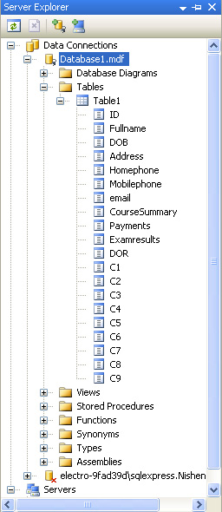

## System Development

* This software was developed using C# language
* Microsoft Visual Studio 2008 was used.

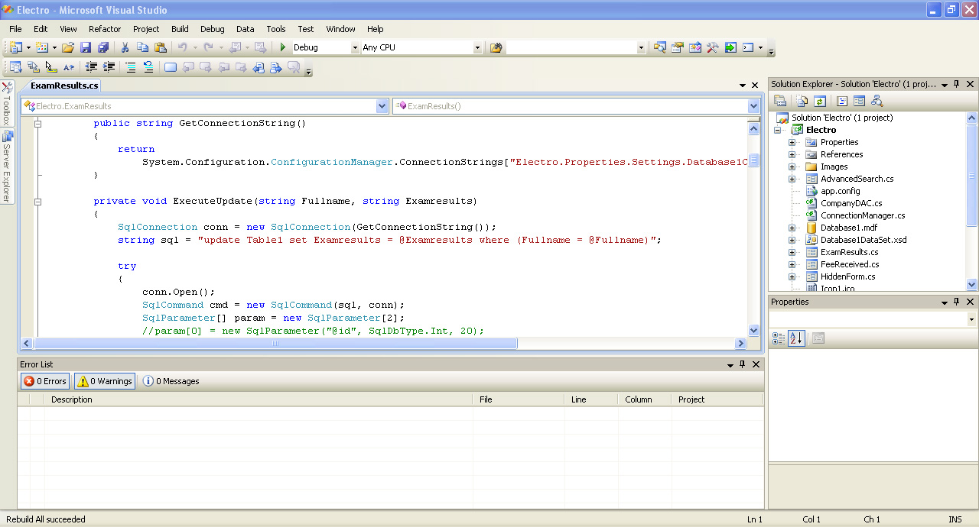

* Microsoft sql server was used to design and edit database.

## Testing

#### Coding Errors

* Coding errors were tested using C# Compiler of Microsoft Visual Studio 2008.

#### Runtime Errors

Few Runtime Errors were found when debugging the software with Microsoft Visual Studio 2008.

Most of them were regarded with Databases especially when adding data to and retrieving data from databases. The most common reason was some coding errors regarded to connection strings.

By checking phrases regarding Connection Strings, those runtime errors were corrected.

#### Requirement Errors

Some Requirement Errors were found and they were corrected by adding some new user controls and codes.

#### Accuracy of the output

This check was performed by adding values to the components and checking whether the expected output can be achieved.

## Implementing the System

### System Requirements

Before installing the software, please check whether the computer meets the following System Requirements.

* Any version of Microsoft Windows 7 must be installed.
* Input Devices – Mouse & Keyboard
* A monitor compatible with higher than 800*600 resolution.

System implementation can be done in either Direct Implement Method or Parallel Implement Method.

### Direct Implement

Because the existing system is a manual system, new computerized system can be implemented on a computer. One person can smoothly handle the whole system using that computer.

### Parallel Implement

Because the old system is already implemented, while continuing the old system, establish the new computerized system. Then records can be inserted using both manual and computerize systems.

If the new system is functioning well, just continue the new computerized system and stop the old system.

## System Maintenance

* The computer on which the software is installed must be maintained well.
* For the safety of records in the software it is good to backup the records.
* Keep the computer secured with a latest firewall solution.

## Interfaces of this Software

#### Welcome Page.

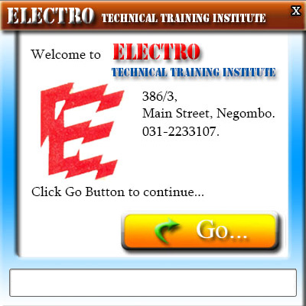

##### Tips for working with this interface

All you have to do is Just click on the Go Button…

#### Sign in Page

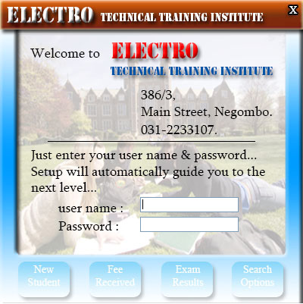

To make this software more secure and more reliable, it is protected with a password.

The correct username and password is essential in order to proceed with this software.

Therefore any unauthorized accesses will be denied.

##### Tips for working with this interface

Just enter your username and password in relevant textboxes. No need to click on any button…

Software will automatically identify the username and password you entered, check it. If your username and password matches, the next page will be displayed. Otherwise you have to try again.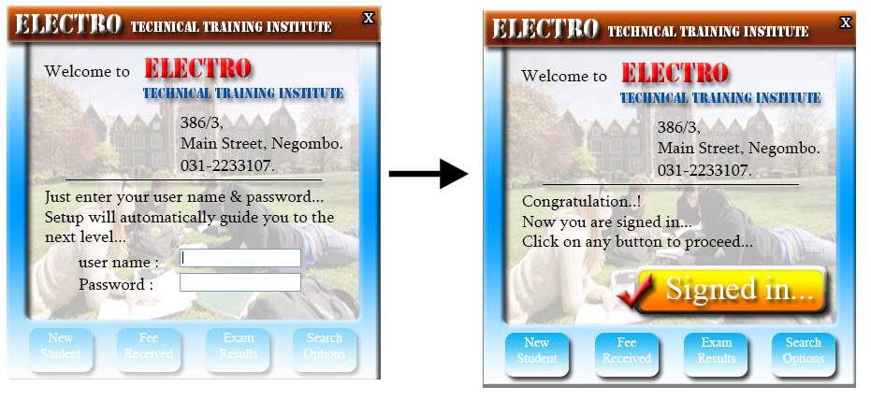

#### Select Task

Click on any of the following buttons.

1. New Student
2. Fee Received
3. Exam Results
4. Search Options

#### Register Students

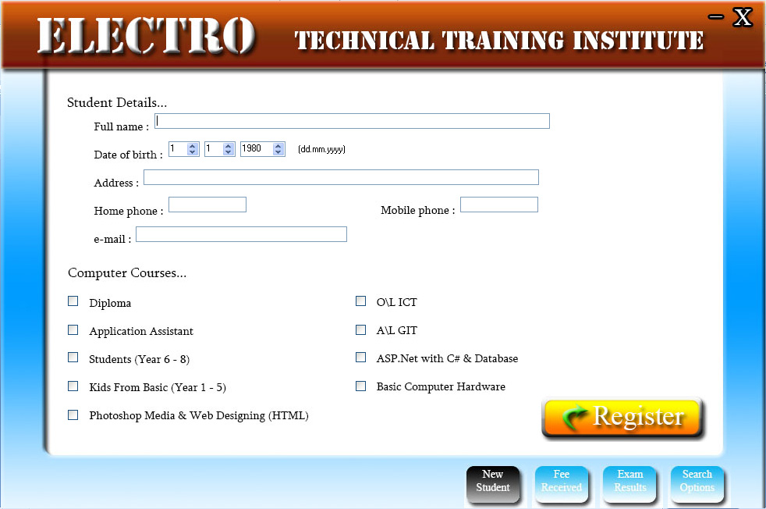

##### Tips for working with this interface

Fill this form. Then click on Register Button.

All the Details you entered will be added to the Database and you will receive a telling you that.

You may leave other fields empty except Full Name field.

It is compulsory to fill the Full Name field.

#### Fee Received

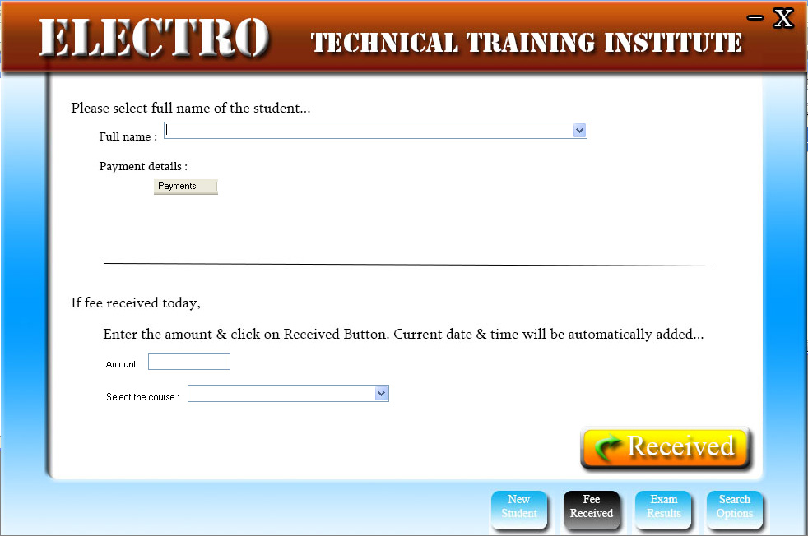

##### Tips for working with this interface

The upper section of this form provides you details of already paid class fees. Paid amount and Date & Time of payment will be shown.

You can use the lower section of this form to store details of newly paid fee.

Enter the amount and Select the course, then hit Received Button.

#### Exam Results

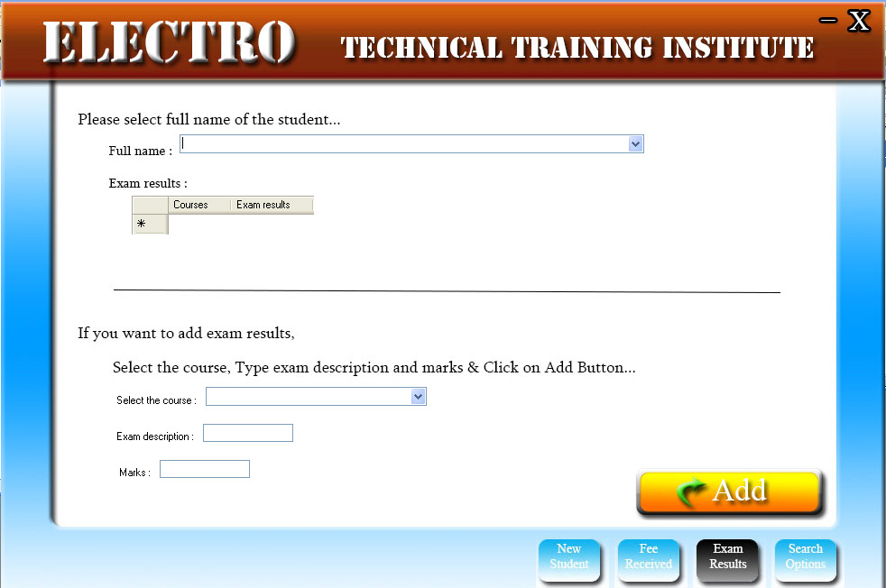

##### Tips for working with this interface

The upper section of this form allows the use to get information about all the held examination regarding each course which the selected student follows.

You can use the lower section to add records about newly held examinations.

Just follow the onscreen instructions.

#### Search Options

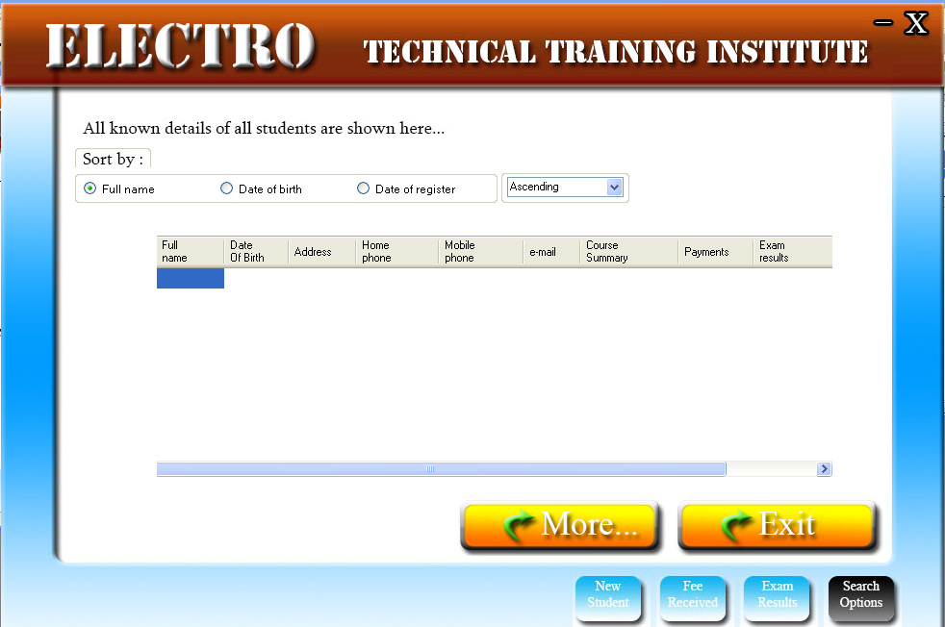

##### Tips for working with this interface

All the details of all registered students will be shown. 6 Order By methods are provided to make this software more easy to use.

Anyhow if you feel difficult to handle a large number of records this way, click on More Button.

That page will make it easy for you.

#### Advanced Search Options

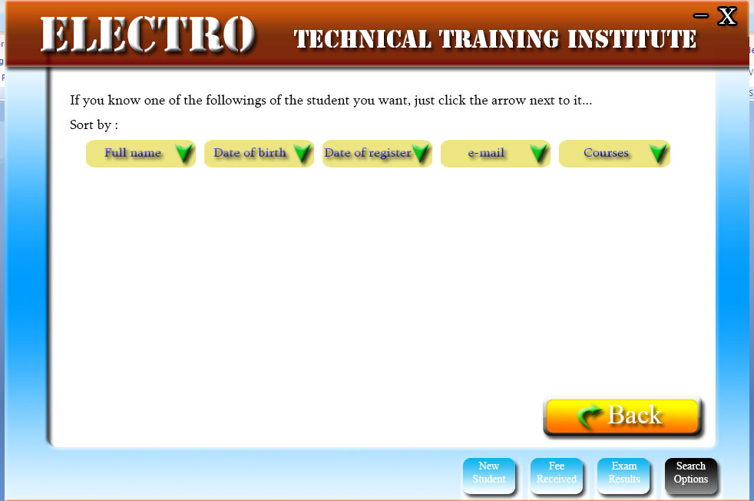

##### Tips for working with this interface

If you know any of the followings, just click the relevant button, enter what you know and click on show.

You will definitely find what you are searching for.

# The End.